Function Families
Look at all the function families below. Hopefully you’ve worked with them before. In this course you’ll need to have an intuitive sense of the shapes and basic characteristics of each of these families. You’ll sometimes need to recognize which of these is happening in a situation. Often you’ll want to control something to do what you want and you’ll need to decide which of these families you’ll use to build your control equations. You’ll also be thinking about more general questions about what is and isn’t possible when working with types of functions, or combining them together in different ways.

Here are some things you’ll want to know. Not just know, but feel.
- The basic overall shape
- How the basic shape changes if you adjust parts of the equation.
- Important reference points (eg (0, 0) or (0, 1) or (1, 1))
- What growth triangles looks like in the curve (what type of growth they have)
- X and Y intercepts (if there are any)
- Asymptotes (if any)

Constant functions  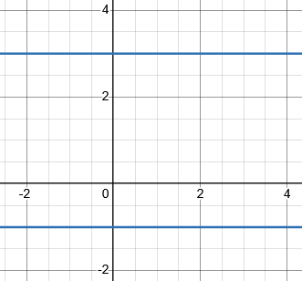  $y=3$  $$y=-1$$  In general:  $$y=k$$  for a real number k | Linear functions  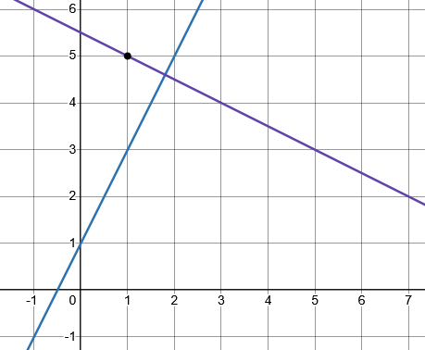  Slope intercept form  y = mx + b  Point slope form  y = m(x – h) + k
Even powers  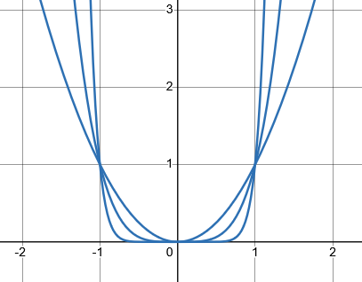  $$y=x^{2}$$  $$y=x^{4}$$  $$y=x^{6}$$ |  | Odd powers  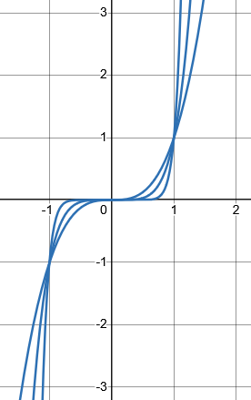  $$y=x^{3}$$  $$y=x^{5}$$  $$y=x^{7}$$
Even roots  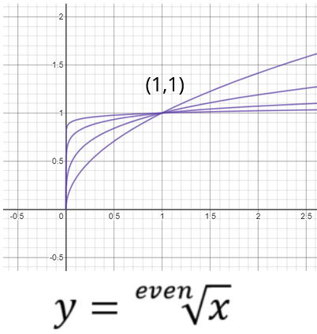 |  |  | Odd roots  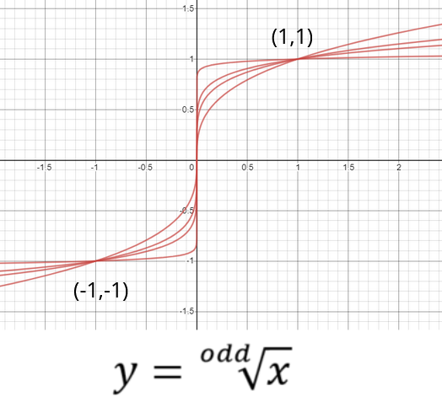
Exponential functions  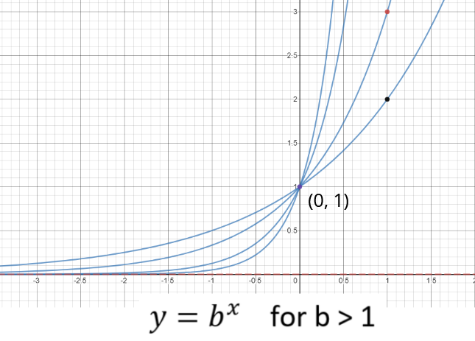 |  |  | Logarithmic functions  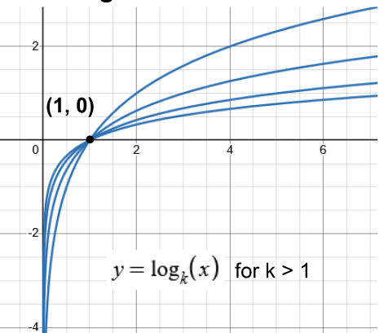
The $\frac{1}{x}$ function (reciprocal function)  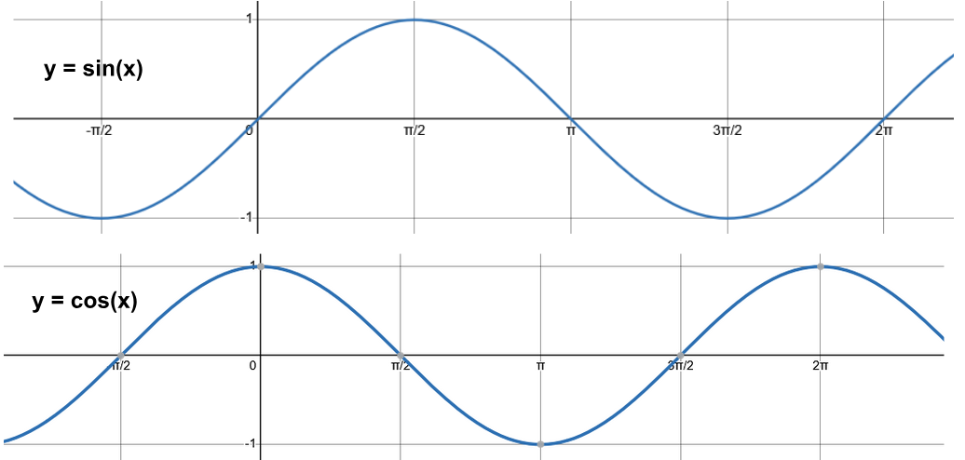  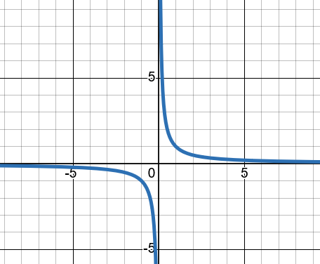 |  |  | Sine and cosine

